Deletion or Insertion of amino acids without the involvement of restriction enzyme sites
- Design primers as indicated:
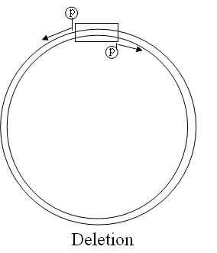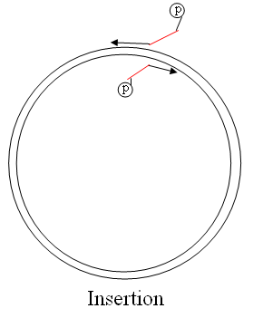
- Run PCR as following (strategene mutagenesis kit):
10x buffer: | 2.5 ul
DNA: | 1 ul (prediluted 1:5)
Primer1: | 0.625 ul (stock solution 100ng/ul)
Primer2: | 0.625 ul (stock solution 100ng/ul)
H2O: | 19.25 ul
DNTP: | 0.5 ul
Pfu Turbo: | 0.5 ul
- Digest parental DNA with 0.5 ul DPNi for >2hr 37oC.
- Gel purify the PCR product, do blunt ligation:
5x buffer: | 4 ul
DNA: | 5 ul
Ligase: | 1 ul
H2O: | 10 ul
- Do transformation

Deletion and Addition Inserts
Deletion and Addition using Site-direct mutagenesis Kit from Strategene
- 10x buf: 2.5
- DNA (miniprep): 1, 1(1/5), 1(1/10).
- primer1 (100ng/ul): 0.625
- primre 2 (100ng/u): 0.625
- H2O: 19.25
- dNTP: 0.5
- pfu Turbo: 0.5

***
mix 4 groups: 10xbuf, primer1, primer2, H2O: 2.5X4=10, 0.625X4=2.5, 0.625X4=2.5, 19.25X4=77, aliquote 2.5+0.625+0.625+19.25=23 to each tube. Add Dntp mix, DNA, pfu Turbo: 0.5, 1, 0.5
Run program Prset:
- cycle 1, 95oC, 30 sec
- cycle 18, 95oC, 30 sec
  - 55oC, 1min
  - 68oC, 12 min

***
group 2 gives the best results.

